TO: Dr. Stewart Whittemore

FROM: Ellie Morton & Huan Liu

DATE: March 18, 2025

SUBJECT: Client Project UX Strategy

Since we updated the Client Project plan last week, we have been working on the website redesign, creation, and structures. Our team has scheduled two online meetings of more than one and a half hours to communicate these procedures. In this memo, we will share our **User Personas, Sitemap for our website, Task Flows, and Wireframes of major pages.** Please see each of the sections below.

### User Personas

According to Ritter and Winterbottom, a persona refers to “the target market or segmentation of a campaign or brand” and is used to describe the user groups to which a product is marketed. For our website, we created an image with the identity of a college student, Amy, which indicates that all users are language learners. Please see more details of the persona below:

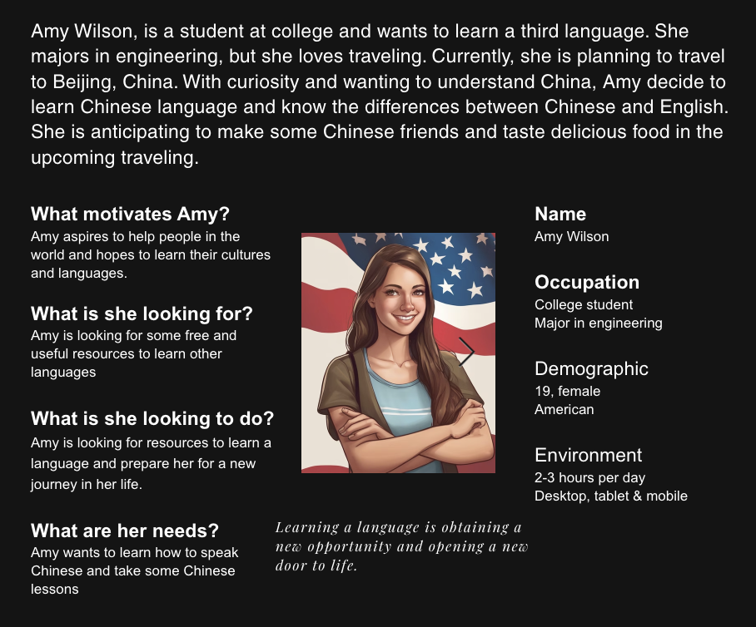

### Sitemap:

For the sitemap, we didn’t change the general structure and content, but we may change the layout of the pages along with our website creation:

* Navigation Pane
* Header
* Welcome/Home Page
* About ESL
* Mission Statement
* Where to Find Us (location and time)
* Class Offered (English, Spanish, and Chinese)
* Lesson Plans (English, Spanish, and Chinese)
* Activities (English, Spanish, and Chinese)
* Footer

*Navigation Pane*

The ‘Navigation Pane’ will include easy access to the other pages offered for a quick and direct way of seeing what their ESL program offers. The tabs are organized from left to right with the most beneficial information at the far left and the least at a respected far right. The goal of the navigation pane is to offer users an overall more efficient experience, receiving their desired information as quickly as possible.

*Header*

Based on the page, the header element will be used differently. On all paged, the header element will include the pages title. If more information is needed for that page, an explanation will be located under the page title within the header.

*Home Page*

The Home Page will feature a header with a page title and some information about the ESL program. It will feature images of learners and volunteers working together.

*About ESL*

‘About ESL’ will elaborate on what the Church offers to prospective learners. This will include brief examples of what learning at Trinity Lutheran Church looks like, as well as images to accompany the explanations for a visual appeal.

There will also be a segment included for the different classes offered and an explanation of what those classes look like for future learners to know where they need to begin.

*Mission Statement*

The ‘Mission Statement’ will be used directly from the Church’s original website to keep a cohesive look from each platform.

*Where to Find Us*

‘Where to Find Us’ will include a header with the page title. The address to the church will be provided as well as a map, for better visual access. The time of meetings will also be included within this page for learners and volunteers to easily access.

*Class Offered*

On this page, ESL learners can find guidance for different levels of classes and videos of lessons. As mentioned, at least three language learning materials will be listed and detailed on this page, such as English, Spanish, and Chinese.

*Lesson Plans*

‘Lesson Plans’ will have a header with the page title as well as include PDFs of existing lesson plans as examples of what to expect when joining for the first time. These will be downloadable, thus allowing others to print them for personal use or future use in teaching. These lesson plans will have an accompanying description of what topic and ‘level’ (ESL1 or ESL2) they correspond with.

*Activities*

‘Activities’ will have a header with the page title as well as PDFs with example activities for other learners and volunteers to use or get inspiration from. These activities will be categorized based on time they take (ranging from 10-12 minutes). They will also be downloadable if users would like to print them for their own use.

*Footer*

The footer will detail two distinct informational columns for each location and a contact box.

### Task Flows:

Since users may have different purposes when browsing our websites, we will present a brief Task Flows process that we assumed what they would do on the website. We considered the five key components—ignition point, the focus point, what they already know, what they need, and what they use—in designing the task flows:

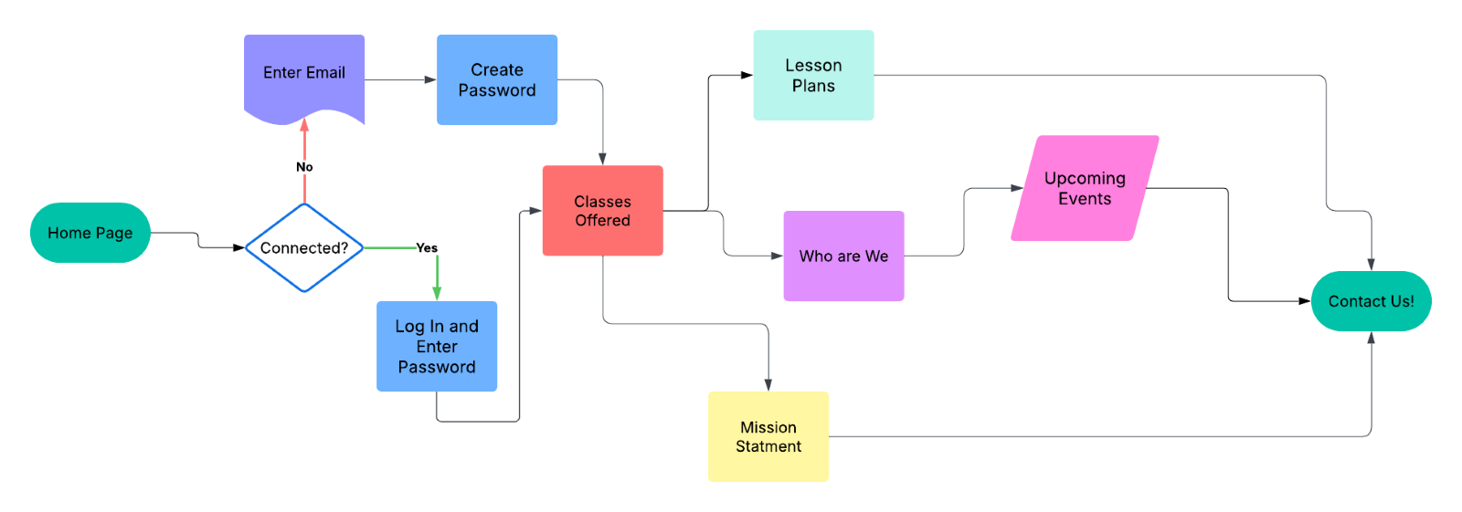

### Wireframes

If you still remember, we created a similar Wireframe with Dreamweaver in the video for our last Client Project Plan. This time, when seeking a way to create a wireframe, we explored Wix and found a template website we liked. We plan to use it for the later design if possible. Please see the screenshots for the major pages below:

#### Home Page:

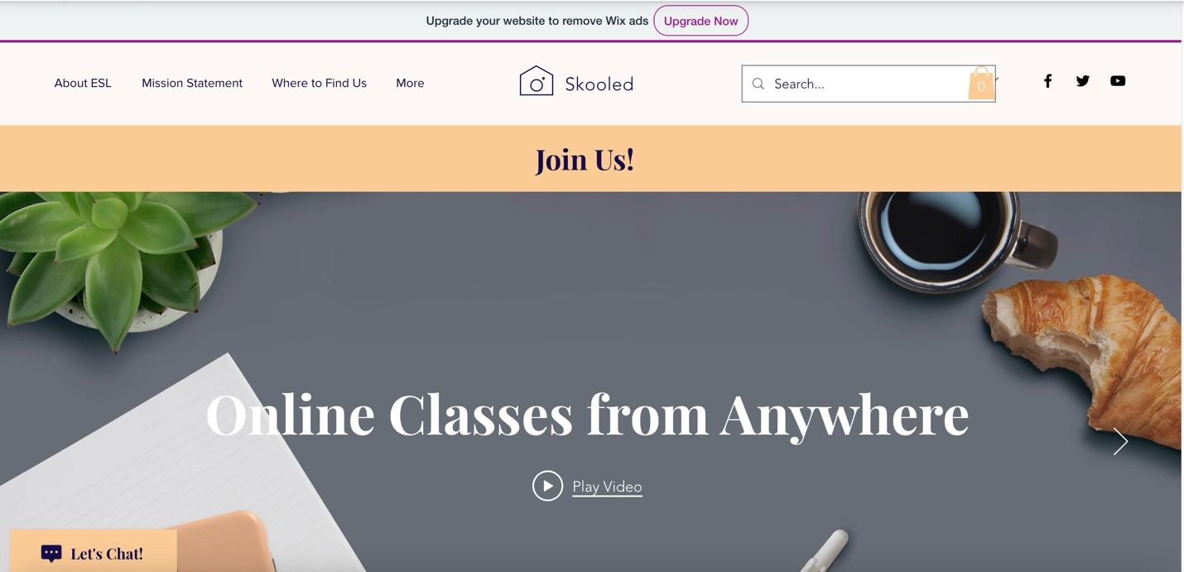

About ELS:

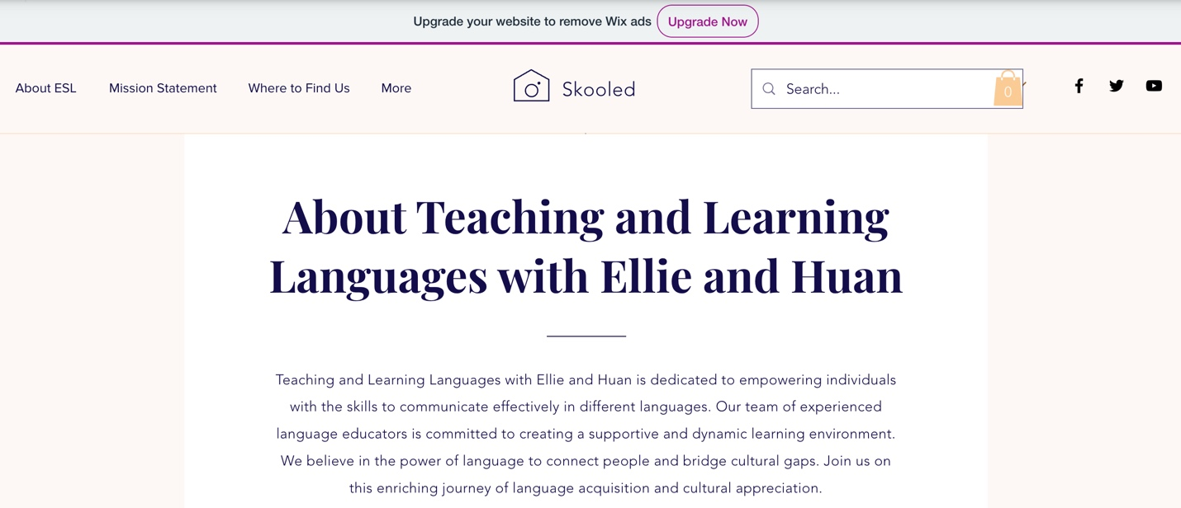

Where to Find Us:

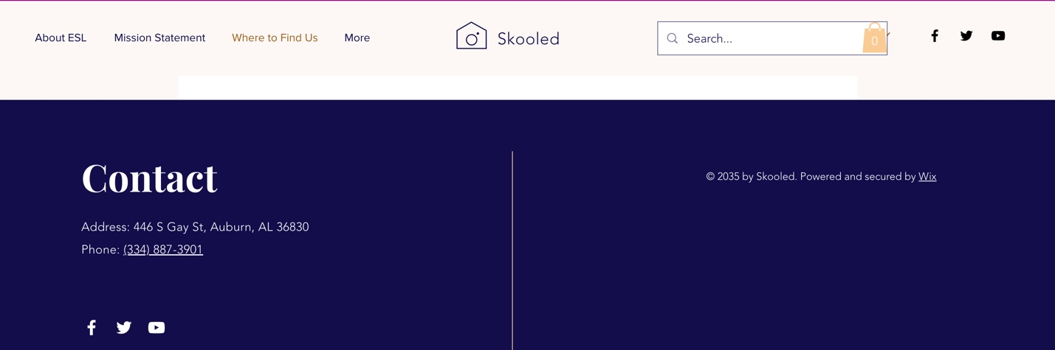

Class Offered:

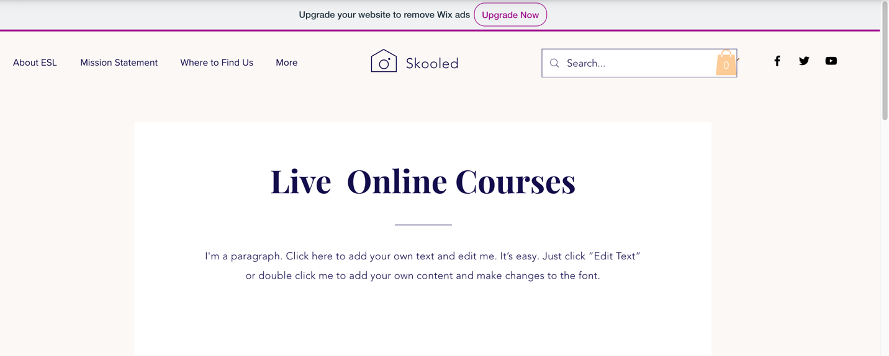

Lesson Plans:

* Our lesson plans are able to be downloaded and saved as PDFs for easy access and printing

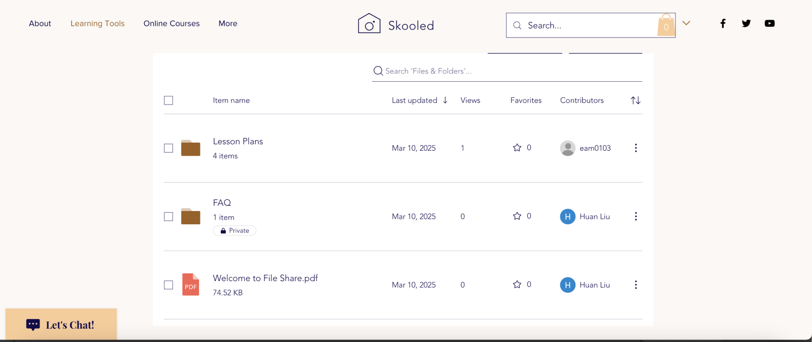

Activities:

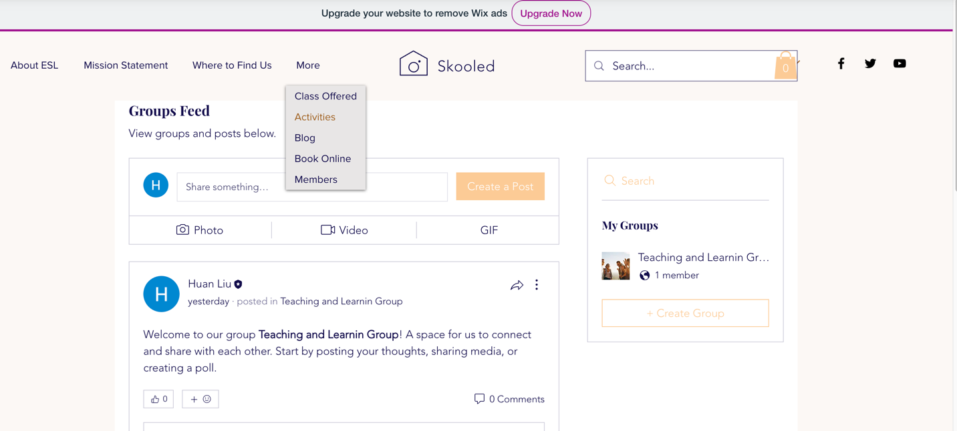

### Conclusion

As it shows above, we have designed the user persona—Amy, and the new website with Wix, as well as the Task Flow and Wireframes. We will follow the UX Strategies guidance to design the prototype and the entire website continuously using Wix in the next few weeks. Additionally, we will be keeping contact with our client and will make some changes according to their feedback. We would like to hear your insights in continuing to work on our project.

Best regards,

Ellie Morton and Huan Liu